# Sprint 5 | 24th November – 30th November

## **Sprint Overview**

### Preview

After our customer meeting at the end of the last sprint, we knew we wanted to finish the core functionality of the game by the end of sprint 5. By splitting the development team with half working on bugs and the other half working on progressing the functionality, we felt we were in a good position to complete this. We also wanted to make the game look more aesthetically appealing by adhering to the dungeon theme. In the last sprint Shawn created a menu screen and a rolling background screen which are planned to be implemented into the game in this sprint. We feel that this will significantly improve the look and user experience of the game.

### Review

In sprint 5, we developed even stronger teamwork. Within one sprint, we created a well-functioning pipe game with pipe generation, rotation, selection, and other features like coin collection, scoring, etc. We also optimized the game art design and UI design with further dungeon themed backgrounds. In this sprint we didn’t have a client meeting, but we still held group meetings to discuss our progress and what we planned to do next. After the group meetings, we all agreed to improve the game in 4 ways: making it harder to win, making it more aesthetically pleasing, making it more entertaining for players, and making it easier to navigate.

## **Tasks**

This sprint was split into two main sections, we spent the first few days of the week focussing on documentation and completing the task S5.1. The second part of the sprint focussed on the more development focussed tasks in S5.2.

### First Tasks

|  |  |  |
| --- | --- | --- |
| Code | Team Members | Tasks |
| **S5.1-T1** | Development Team (Marcus, Zoe, Matthew, Leo) | Create a separate sprint summary section solely for development, to keep track of work and increase transparency for documentation. |
| **S5.1-T2** | Shawn (Chin) | Overview section for sprint documentation, and backgrounds of the menu and the game for development. |
| **S5.1-T3** | Rachan | Amend meeting records to sprint documentation. |
| **S5.1-T4** | Michelle | Write preview section for sprint documentation. |

### Second Tasks

The ongoing tasks at the end of Sprint 4 were encapsulated within the “Other tasks formed from S4.1-T5 + bugs to fix at the end of Sprint 4:” section in Sprint 4. Therefore, they are not explicitly written in the backlog below, but continue to be represented.

|  |  |  |
| --- | --- | --- |
| Code | Team Members | Tasks |
| **S5.2-T1** | Marcus | (prev. S4.2-7-T1 and helps toward S4.2-T2): Allow character to enter both sides of the pipe when rotating. |
| **S5.2-T2** | Marcus | (prev. S4.2-7-T5): Add coin generation. |
| **S5.2-T3** | Marcus | (prev. S4.2-7-T15): Make character appear within pipes rather than in front of them. |
| **S5.2-T4** | Leo | (prev. S4.2-7-T4): Make character die if it touches the top or bottom of the screen. |
| **S5.2-T5** | Zoe | (prev. S4.2-7-T2 and helps toward S4.2-T4): Implement high score saving, and menu/game-over display. |
| **S5.2-T6** | Matthew | (prev. S4.2-7-T18): Add the menu background to the game. |
| **S5.2-T7** | Matthew | (prev. S4.2-7-T19): Add the rolling background (from Shawn) to the game. |

## **Backlog**

|  |  |  |  |  |
| --- | --- | --- | --- | --- |
| Priority | Tasks | Date of Creation | Date of Completion | Status at End of Sprint |
| Dev. Team 1 | S5.1-T1 | 24/11/21 | 25/11/21 | Complete |
| Shawn (Chin) 1 | S5.1-T2 | 24/11/21 | 29/11/21 | Complete |
| Rachan 1 | S5.1-T3 | 24/11/21 | 28/11/21 | Complete |
| Michelle 1 | S5.1-T4 | 24/11/21 | 24/11/21 | Complete |
| Dev Team | **PT1** | 10/11/21 | - | Ongoing |
| (1) Marcus 1 | S5.2-T1 | 21/11/21 | 27/11/21 | Complete |
| (1) Marcus 2 | S5.2-T2 | 21/11/21 | 27/11/21 | Complete |
| (1) Marcus 3 | S5.2-T3 | 21/11/21 | 27/11/21 | Complete |
| (1) Leo 1 | S5.2-T4 | 21/11/21 | 28/11/21 | Complete |
| (1) Zoe 1 | S5.2-T5 | 21/11/21 | 09/12/21  Completed in S7-T2 | Ongoing |
| (1) TBD | S4.2-7-T3 | 21/11/21 | - | Not Started |
| (1) TBD | S4.2-7-T6 | 21/11/21 | - | Not Started |
| (1) TBD | S4.2-7-T7 | 21/11/21 | - | Not Started |
| (1) TBD | S4.2-7-T8 | 21/11/21 | - | Not Started |
| (1) TBD | S4.2-7-T9 | 21/11/21 | - | Not Started |
| (1) TBD | S4.2-7-T10 | 21/11/21 | - | Not Started |
| (1) TBD | S4.2-7-T11 | 21/11/21 | - | Not Started |
| (1) TBD | S4.2-7-T12 | 21/11/21 | - | Not Started |
| (1) TBD | S4.2-7-T13 | 21/11/21 | - | Not Started |
| (1) TBD | S4.2-7-T14 | 21/11/21 | - | Not Started |
| (1) TBD | S4.2-7-T16 | 21/11/21 | - | Not Started |
| (1) TBD | S4.2-7-T17 | 21/11/21 | - | Not Started |
| Dev Team | **PT2** | 10/11/21 | - | Ongoing |
| (1) Matthew 1 | S5.2-T6 | 17/11/21 | 02/12/21  Completed in S6-T5 | Ongoing |
| (2) Matthew 2 | S5.2-T7 | 21/11/21 | 02/12/21  Completed in S6-T6 | Ongoing |
| (2) TBD | S4.2-7-T20 | 21/11/21 | - | Not Started |
| (2) TBD | S4.2-7-T21 | 21/11/21 | - | Not Started |
| (2) TBD | S4.2-7-T22 | 21/11/21 | - | Not Started |
| (2) TBD | S4.2-7-T23 | 21/11/21 | - | Not Started |
| Dev Team | **PT3** | 10/11/21 | - | Not Started |

## **Meeting Records**

|  |  |  |  |
| --- | --- | --- | --- |
| Overview | Duration | Date & Time | Attended By |
| Internal meeting | 80 minutes | Wednesday (24th November 2021) - 12:00 – 13:20 | All Team members |
| Internal meeting | 60 minutes | Sunday (28th November 2021) - 15:30 - 16:30 | All Team members |
| Internal meeting | 60 minutes | Tuesday (30th November 2021) - 18:00 - 19:00 | All Team members |
| Internal meeting | 90 minutes | Wednesday (1st December 2021) - 17:00 – 18:30 | All Team members |

## **Customer Interview and Analysis**

We did not have a customer meeting in sprint 5. Instead, we hosted our own additional group meeting and assigned the tasks for this sprint.

## **User Stories**

The User Story, R5, was updated to include character death at the top and bottom of the screen.

### R5

|  |  |
| --- | --- |
| User Story: Character Dying R5 | Acceptance Criteria |
| As a Game Developer,  I want to kill the character if he falls too far behind,  So that the player has the goal to keep them alive. | Criterion 1.  **IF** the character is alive…  **WHEN** the character touches the left-hand edge of the screen…  **THEN** declare game over.  Criterion 1.  **IF** the character is alive…  **WHEN** the character touches the top edge of the screen…  **THEN** declare game over.  Criterion 1.  **IF** the character is alive…  **WHEN** the character touches the bottom edge of the screen…  **THEN** declare game over. |
| Priority: 5/5  Version: 2  Date: 29/11/21 |

## **User Story Tests**

The following tests were completed at the end of Sprint 5. If the User Story’s acceptance criteria are fulfilled, the test was passed.

|  |  |  |
| --- | --- | --- |
| User Story | Test Result (acceptance criteria) | Reason for failure |
| R1 | Pass | - |
| R2 | Fail | No pipe highlighting for selected pipes. |
| R3 | Pass | - |
| R4 | Pass | - |
| R5 | Pass | - |
| R6 | Pass | - |
| R7 | Pass | - |
| R8 | Pass | - |
| R9 | Fail | The player’s high score is not saved so cannot be displayed. |
| R10 | Pass | - |
| R11 | Pass | - |
| R12 | Fail | No pause or resume button implemented. |
| R13 | Fail | No obstacle functionality implemented. |
| R14 | Fail | No restart buttons implemented. |
| R15 | Fail | No home buttons implemented. |
| R16 | Pass | - |
| R17 | Fail | No special pipe functionality implemented. |
| R18 | Fail | No beat bonus functionality implemented. |
| R19 | Fail | Pipe generation does not increase in speed. |
| R20 | Fail | Number of pipes generated does not increase wit time. |
| R21 | Fail | Camera moves to right but not at increasing velocity. |
| R22 | Fail | High score is not saved. |
| R23 | Pass | - |

## **Use Cases**

The Use Case 13 was updated to include character death at the top and bottom of the screen.

### Use Case 13

**UC13 - Version 2**

|  |  |  |
| --- | --- | --- |
| **UC13-1** | Use Case | Player loses the game – UC1 Step 5, 6 & 7- (medium-level) |
| **UC13-2** | Author | Zoe Broad |
| **UC13-3** | Date | 29/11/21 |
| **UC13-4** | Purpose | The player should be able to lose the game, otherwise it would become boring. |
| **UC13-5** | Overview | Starts when the system starts the game. System generates obstacles (similar to UC5 with pipes). The player adds a pipe to the system (see UC3,4,5,6, and 7). The system moves the character through the pipe (see UC8). The system is triggered when the character touches an obstacle else Alternative 1: The system is triggered when the character touches the top, bottom, or left-hand side of the screen. The system declares a game over state. System stops generating new obstacles. |
| **UC13-6** | Cross Reference | R5, R13 |
| **UC13-7** | Actors | Player |
| **UC13-8** | Pre-Condition | UC13-Pre-1: The system is in the progress of starting the game. |
| **UC13-9** | Post-Conditions | UC13-Post-1: The system is in a game over state. |

|  |  |  |
| --- | --- | --- |
| **Actor Actions**  3. The player adds a pipe to the pipe system. |  | **System Actions**  1. The system starts a new game.  2. System starts obstacle generation.  4. The system adds a pipe to the pipe system.  5. The system moves the character through the pipe system.  6. The system is triggered when the character touches an obstacle.  7. The system changes to a game over state.  8. System stops obstacle generation. |

|  |  |  |
| --- | --- | --- |
| **UC13-10** | Alternative Flow of Events: | * The system is triggered when the character touches the top, bottom, or left-hand side of the screen. Move to Step 6. |
| **UC13-11** | Exceptional Flow of Events: | * The system is triggered by an obstacle collision, and a screen collision. The system should move to Step 6. |

## **Use Case Tests**

The following test was completed at the end of Sprint 5. The test passes if the use case runs as defined.

|  |  |  |
| --- | --- | --- |
| Use Case | Test Result | Reason for failure |
| UC1 | Fail | The high score has not been recorded by the system. |
| UC2 | Pass | - |
| UC3 | Pass | - |
| UC4 | Fail | Pipe piece is not highlighted when selected. |
| UC5 | Pass | - |
| UC6 | Pass | - |
| UC7 | Pass | - |
| UC8 | Pass | - |
| UC9 | Fail | Pausing and resuming not implemented. |
| UC10 | Fail | No home button to take player to main menu from game over state. |
| UC11 | Fail | No way to restart the game from the beginning whilst in game. |
| UC12 | Fail | System does not validate or store high score. |
| UC13 | Pass | - |
| UC14 | Pass | - |
| UC15 | Pass | - |
| UC16 | Pass | - |

## **User Interface Design**

### Game Progress

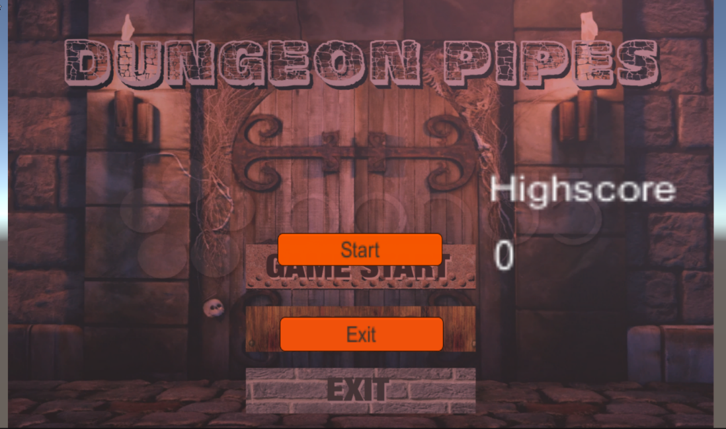

Main Menu

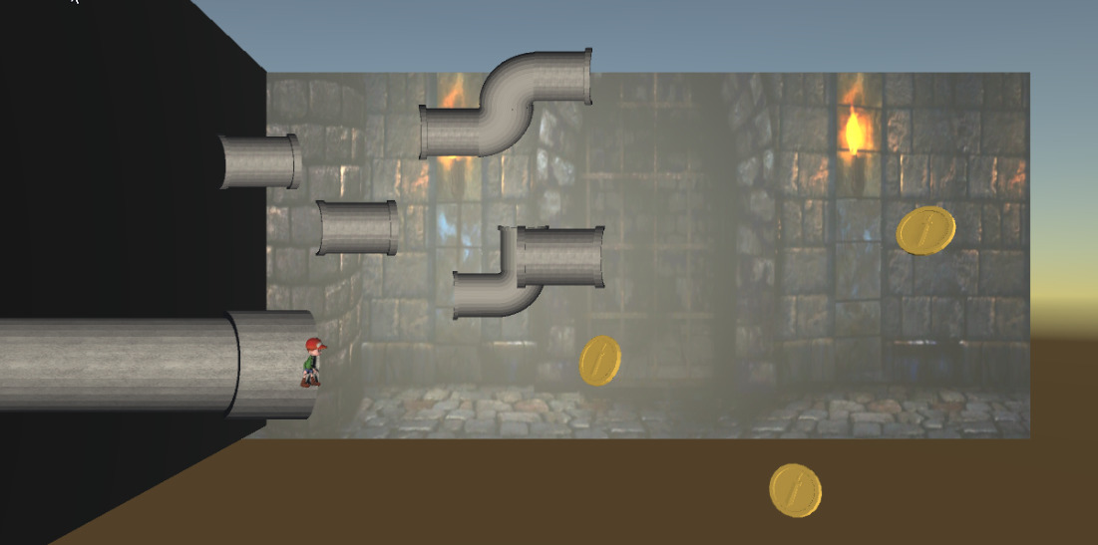

Updated game design

### Coin design in Blender

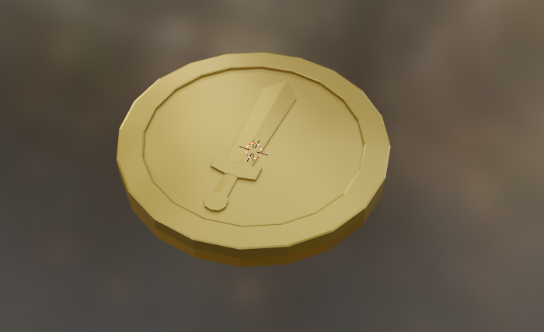

## **Exception Handling**

The challenges we faced during this sprint’s tasks are outlined below, alongside their respective solutions:

|  |  |  |
| --- | --- | --- |
| Tasks | Challenges | Solutions |
| S5.1-T1 | Organising all the content. | Planning the content creation before making any. |
| S5.1-T2 | N/A Fairly straightforward. | - |
| S5.1-T3 | N/A Fairly straightforward. | - |
| S5.1-T4 | N/A No challenges. | - |
| S5.2- T1 | 1) Check if pipes can be added from either side.  2)If pipe is added backwards the position it attaches from needs to change. | 1) Use the position of both the entry and exit of the pipe and check it against the position of main pipe exit.  2) If the pipe is reversed, first add it at the parent checkpoint (start of pipe) then move it by the difference in distance between the first and last checkpoint. |
| S5.2- T2 | Keep coin rotation and depth the same for all coins. | Create an empty game object with the coin prefab inside at the correct position, then instantiate this game object rather than the coin prefab. |
| S5.2-T3 | Some turning pipes did not scale as expected, for example the S shape pipe would not scale correctly along the Y axis. | Break the pipes down into smaller segments that could scale correctly then combine them all under one parent object. |
| S5.2-T4 | N/A Fairly straightforward. |  |
| S5.2-T5 | N/A No challenges. | Ongoing. |
| S5.2-T6 | Adding the image to the menu was relatively simple, the only issue being the plane had the wrong dimensions for the image. | Resize the menu and camera so the image did not appear to be stretched. |
| S5.2-T7 | Creating enough planes for the background to go on forever. | Ongoing. |